[PROJECT NAME] Web App
ANALYSIS AND DESIGN DOCUMENT

Team 1
John Doe
Jane Doe

Contents
Contents 2
Introduction 3
System Architecture 4
System Overview 4
Architectural Design 4
Decomposition Description 4
Design Rationale 4
Human Interface Design 4
registration 5
INPUT & OUTPUT 6
Actions 6
Pre and Post Conditions 6
Validation 7
LOGIN 7
INPUT & OUTPUT 7
Actions 8
Pre and Post Conditions 8
Validation 8
CHANGE PASSWORD 8
INPUT & OUTPUT 9
Actions 9
Pre and Post Conditions 10
Validation 10
Component Design 10
Entities 11
Data Design 11
Data Description 12
Registration / Authentication 12
DATABASE Dictionary / SCHEMA 13
Registration / Authentication 14
Full DAtabase Model 15
Requirements Matrix 16
Appendices 16

Description: The ADD is the second document that each group will submit regarding the class project. Each group will work with one (1) feature per team member. For each feature, you will need to design each of the “Use Cases” you worked for the SRS document.
The document should include the following items:

Introduction
- Purpose
Identify the purpose of this ADD and the intended audience. This subsection should explain the purpose for writing an ADD for this project and describe the intended audience for the ADD.
- Scope:
Restate from the SRS, the goals and objective
Identify which components are being developed and that are part of the project, and which ones are not.
List all three modules included in the design and who is in charge of each module
- Overview/References:
Provide an overview of how the document in organized
Include any referenced used to create the document
- Definitions and Acronyms:
[Optional] Include definitions for terms used throughout the document.

System Architecture
(This section is only one per group)
- Write a High level description of the system involving modules and components.
- Include Context diagrams with description of the architecture planned.

System Overview
Give a general description of the functionality, context and design of your project. Provide any background information if necessary.

Architectural Design
- Develop a modular program structure and explain the relationships between the modules to achieve the complete functionality of the system. This is a high level overview of how responsibilities of the system were partitioned and then assigned to subsystems.
- Identify each high level subsystem and the roles or responsibilities assigned to it.
  - Describe how these subsystems collaborate with each other in order to achieve the desired functionality.
  - Don’t go into too much detail about the individual subsystems. The main purpose is to gain a general understanding of how and why the system was decomposed, and how the individual parts work together.
- Provide a diagram showing the major subsystems and data repositories and their interconnections. Describe the diagram if required.

Decomposition Description
Provide a decomposition of the subsystems in the architectural design. Supplement with text as needed. You may choose to give a functional description or an objectoriented description. For a functional description, put toplevel data flow diagram (DFD) and structural decomposition diagrams. For an OO description, put subsystem model, object diagrams, generalization hierarchy diagram(s) (if any), aggregation hierarchy diagram(s) (if any), interface specifications, and sequence diagrams here.

Design Rationale
Discuss the rationale for selecting the architecture described in 3.1 including critical issues and trade/offs that were considered. You may discuss other architectures that were considered, provided that you explain why you didn’t choose them.

Human Interface Design
- Detailed definition of the system requirements specification for each use case. Each use case should be mapped to a component (or page) with the expected input and outputs, the Actions taken as part of the component execution and the pre-conditions.
  - Overview of User Interface. Describe the “page” or “form”
  - Screen Images (wireframes, mocks, drawings). Draw a mock or wireframe of the page/form
  - Describe page/form behavior: Screen Objects and Actions: should include all buttons, input fields, menu options:
  - Describe each Input and Outputs (every field for every page is included) with data types/length/attributes
  - Actions or execution: Describe the business rule and algorithms for the actions
  - Pre and Post Conditions: Similar to the SRS, make sure all assumptions are accounted for
  - Validations: Describe all rules and every field that must be validated. For example, which fields are required, what kind of validation must be included (valid phone number or SSN or email address)
  - Different actors cases need to be included (client and administrator)

Account Management Feature

Registration Use Case
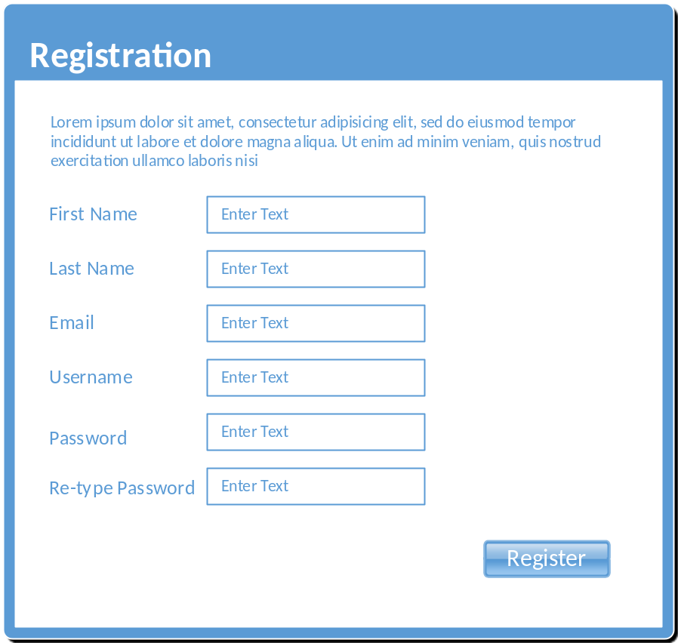
The registration page will allow new users to register with the system. The user must enter all fields before submitting the form.

INPUT & OUTPUT

Input:
- First Name: String representing the first name of user. Minimum of 1 and maximum of 50 characters.
- Last Name: String representing last name of user. Min 1 and maximum 50 characters
- Email: User’s email address used for communication and verification. Should match standard email pattern “name@server.com”. Minimum of 10 characters, maximum of 50 characters.
- Username: string representing the username can be a minimum of 6 characters and a maximum length of 20.
- Password: Also a string. Must be a minimum of 8 characters and a maximum of 20. Must contain on capital letter and one number.
- Re-enter Password: matches Password field. Used only for verification of password.

Output:
Upon successful creation of user, the system will display a welcome message or a warning message. In addition, if the data entered is not valid, the system will show a list of the fields with invalid data in red font.
Possible messages:
Successful: “Welcome [First Name] [Last Name]. Thank you for registering with us!”
Failed: “There is an error with your information. Please review the fields highlighted in red and re-enter the information”

Actions
Upon submitting the form, the system will validate that all required fields have input, and that each field matches the required data in the required format.
If the validation is successful, the system will run a query to store the user’s information in the database.
If the validation failed, the system will abort transaction and return an error message for each invalid field.

Pre and Post Conditions
Pre-conditions: User has not registered with the system already. The system should validate that the email and username are unique within the stored user values.
Post-conditions: User record is stored successfully. A user session is created.

Validation
The following validations will be performed on the submitted data:
- First Name, Last Name: fields must be at least the minimum specified length and no more than the maximum length.
- Username: must be unique
- Email: must be unique and must meet standard email address format
- Password: Must meet standard strong password policy. The password must be stored using a secure mechanism that will prevent unauthorized access. All passwords will be hashed and stored as such in the database.

LOGIN Use Case
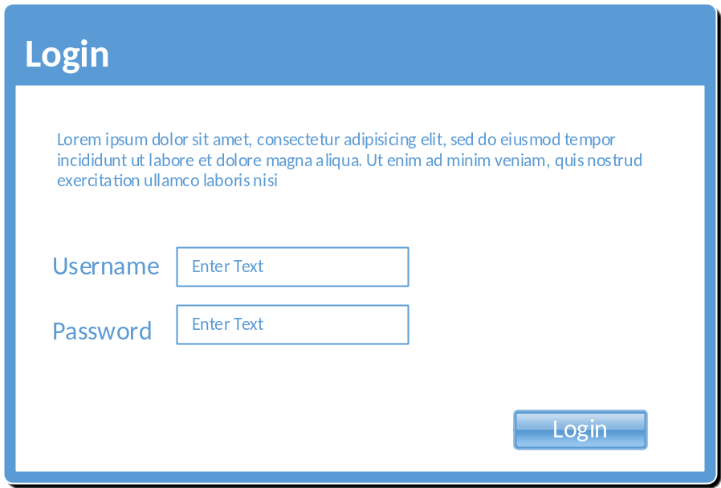
The login page will allow students/faculty to access the system’s features. They can also rest their password or unlock their account.

INPUT & OUTPUT

Input:
- Username: string representing the username can be a minimum of 6 characters and a maximum length of 20.
- Password: Also a string. Must be a minimum of 8 characters and a maximum of 20. Must contain on capital letter and one number.

Output:
A session is created for the successful logged in user to access information granted to the specific user role. Also a message welcoming the user or an error (depending on the credentials provided)

Actions
Once the user has entered their user name and password, the “Login” button will prompt the site to authenticate the user. Their role will be determined and they will be granted access to the modules available to that class of user. Based on the assigned role, the user might be re-routed to the faculty page or the student page.

Pre and Post Conditions
Pre-conditions: Faculty and students both require a valid user name and password, the user name will be assigned upon acceptance or employment to the institution.
Post-conditions: Successful entry of credentials will result in a portal page. Unsuccessful entry of credentials will result in an error page, where the user is required to re-submit credentials.

Validation
Both the user name and password will be validated by comparing them to the specific user credentials stored in the database.
Password Security: The password must be stored using a secure mechanism that will prevent unauthorized access. All passwords will be hashed and stored as such in the database.

CHANGE PASSWORD Use Case
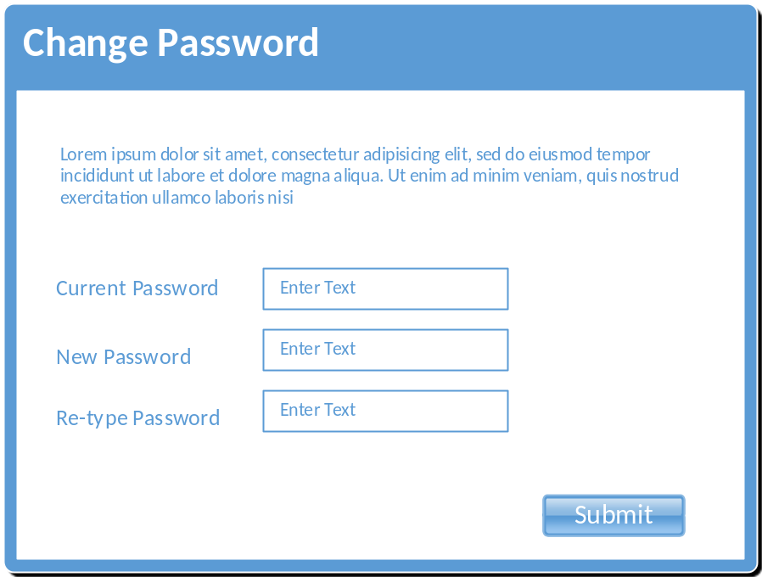
The Change Password page will allow the user to change their password by entering the current one, and the new password.

INPUT & OUTPUT

Input:
- Current Password: String. Must be a minimum of 8 characters and a maximum of 20. Must contain on capital letter and one number.
- New Password: Also a string. Must be a minimum of 8 characters and a maximum of 20. Must contain on capital letter and one number.
- Re-type Password: Same requirements as New Password

Output:
If the user enter the correct “current password”, the system will store the new password and return a “Successfully change of password” message.

Actions
Upon submission of the form, the system will validate the user has entered the correct password. To do so, the system will use the current session username and retrieve the current password from the database. The “Current Password” entered will be verified against the stored password and if successful, it will also validate both “New Password” and “Re-type Password” values are identical.
If all validation passes, then the system will update the user account with the new password entered.

Pre and Post Conditions
Pre-conditions: User is already registered and the account is active.
Post-conditions: Successful transaction will update the user’s password to the specified new values.

Validation
Current password will be validated against the stored password. New password will be validated against the “Re-type password” value, which should match. Also, new password must meet strong password policy.
Password Security: The password must be stored using a secure mechanism that will prevent unauthorized access. All passwords will be hashed and stored as such in the database.

Component Design
The purpose of this section is to expand on the basic domain analysis done during SRS document creation. For the Component Design, please ensure the following:
- Classes are well defined: The domain includes all classes needed for “each” use case
- Attributes are well defined for each class with access modifiers (private or public attributes)
- Methods are defined with access modifiers (public or private)
- Relationships are well defined (one to many, many to many, etc.)
Describe each class and its relationships.
- - What is the main responsibility of each class?
- - What other classes depend on it, and what other classes this class depends on?
- - What are the main data elements required for the class?
- - Show a detail UML class diagram as shown below.

Account Management Feature
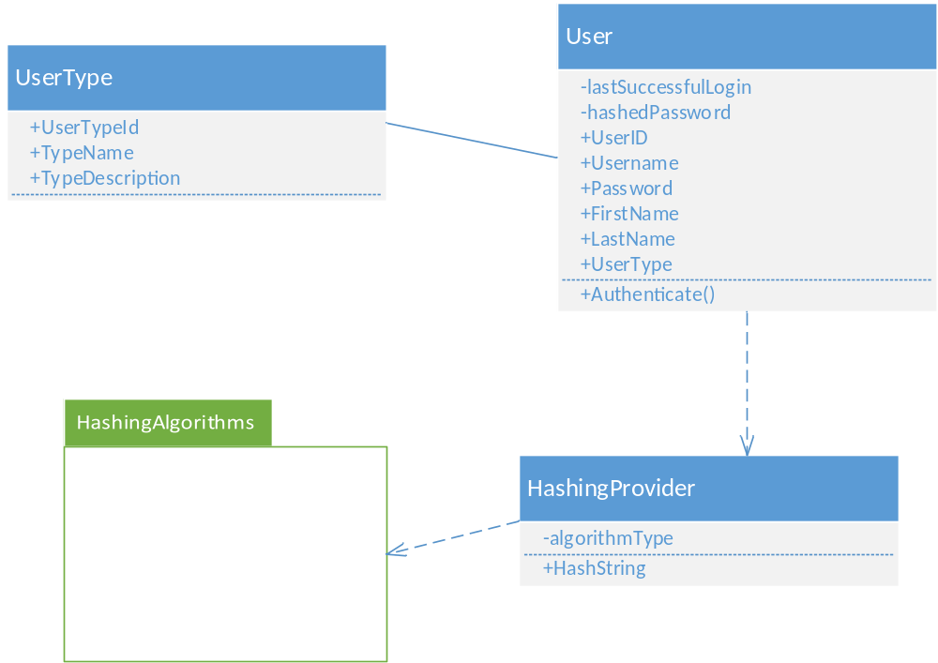

Entities
User: The User class represents both customer and staff entities. It is the base class for all user information. This class is responsible for managing the user personal information as well as defining the formatting of names.
User Attributes/Fields:
- User ID: unique identifier for a single User instance
- FirstName: The first name of the user
- LastName: The last name of the user
- Email: a string representing a valid email address in the form of [account]@[domain].[suffix]
- Username: a unique string chosen by the user to gain access to the system
- Password: a string representing the password selected by the user to gain access to the Web site. It should be no less than 8 chararcters
- UserType: An association to the UserType entity. It defines the type of the current user instance
Relationships:
- UserType: Each user has a one to one relationship with a type entity.
- HashingProvider: The User object will depend on the HashingProvider entity which will hash the passwords for the current user object.
UserType: Entity that identifies one of the possible types of users. Possible options might be “customer”, “admin”, “guest”
HashingProvider: This object will be responsible for hashing the user passwords using one of the standard algorithm. The “provider” will depend on a third party library for the hashing algorithm.
HashingAlgorithms: This package is TBD based on hashing requirements.

Data Design
One per module/feature of the following:

Data Description
- Entity-relationship model (ER model) for each use case
- Include a classic ERD (Entity Relationship Diagram) model for each use case, and make sure you added each entity with its relationship and attributes.
- Make sure that all relationships are defined and accounted for
- Attributes are defined with natural/primary keys
- Model is complete or extensive

Account Management Feature
From the below diagram, we identified a relationship between a user and his/her type. The possible types will be Administrator and Customer. The relationship “IsType” does not include any specific attributes.
Another relationship for the user is the Game Reviews. In this particular relationship, we have unique attributes that are not part of the user and neither are they part of the game. Those attributes are only related to the user review of a game. For example, the Review Description and the When Reviewed attributes are not part of the user, but they do describe the relationship of the user and game through a review.
Please include in the diagram a numeric quantity on the relationships.
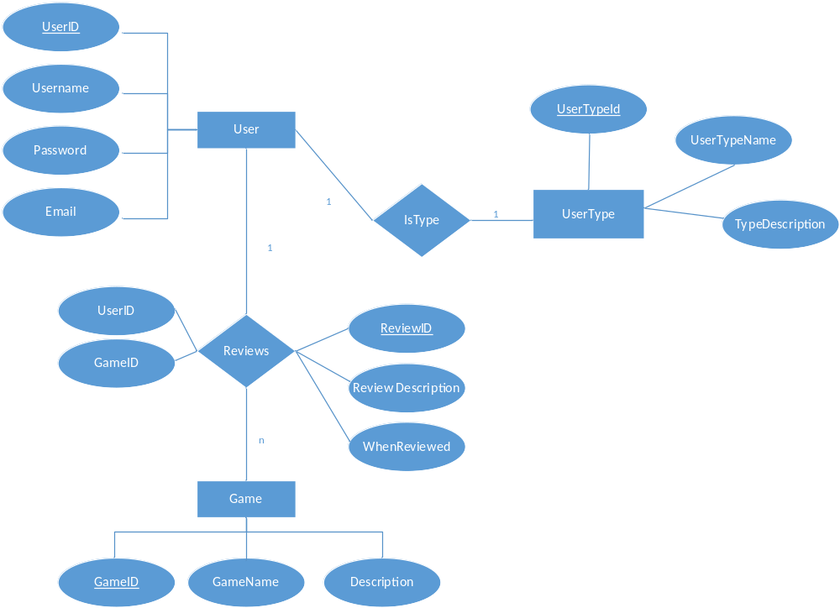

DATABASE Dictionary / SCHEMA
Guidelines:
Schema is well defined for all entities in the ERD
- Fields are well defined, including the data type and the description
- Primary and Foreign keys are defined and included in the diagram
- Relationships are well defined
- Define each table needed for each component or module
- Table fields should be described extensively (data type + dictionary/meaning).
- Identify all primary keys and foreign keys for each table

Account Management Feature
The following tables are defined for the Registration/Authentication module
User Table

Entity | Type | Value | Description
user_id | INT | Not null | PK. Unique identifier of a user.
user_type_id | INT | Not null | FK. Relationship key to the User_Types table
user_pw | varchar(50) | Not null | User’s password HASH
first_name | varchar(30) | Not null | User’s first name
last_name | varchar(30) | Not null | User’s last name
DOB | Date | Not null | User’s date of birth
SSN | varchar(9) | Not null | User’s social security number
Phone | varchar(10) | Not null | User’s phone number
Email | varchar(50) | Not null | User’s E-mail address
Address | varchar(50) | Not null | User’s home address
City | varchar(20) | Not null | City
State | varchar(2) | Not null | State
Zip_code | varchar(5) | Not null | Zip code

User_Types Table

Entity | Type | Value | Description
user_type_id | INT | Not Null | PK. Unique identifier of a user.
type_name | varchar(50) | Not null | The name of the user type
type_description | varchar(50) | Not null | Description of the user type and its uses

Full DAtabase Model
Full entity relationship for ALL MODULES assigned to your group. No need to include dictionary. This entity relationship diagram should include tables for ALL the use cases presented in the SRD. This is the only section of the document where you will be using info from the fall your use cases.
Guidelines:
Include ALL assigned modules
- Include in your diagram
- Relationships are well defined
- Table names
- Fields
- Primary keys (PK)
- Foreign keys (FK)
- Relationships
SAMPLE DIAGRAM (NOT APPLICABLE FOR THIS PROJECT)
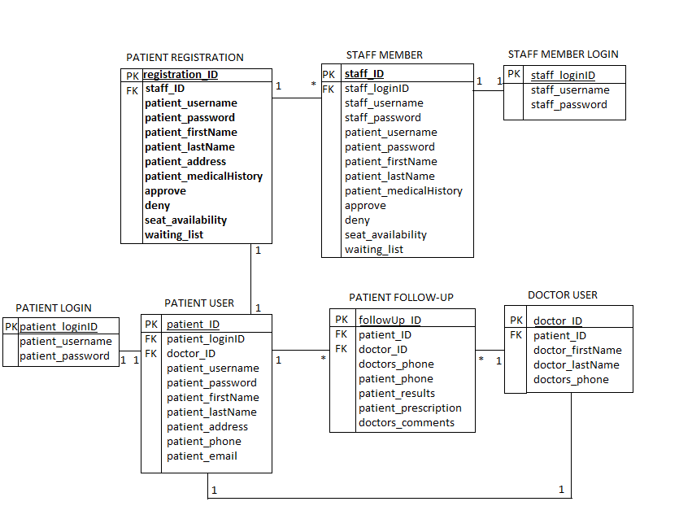

Requirements Matrix
For this section, simply provide a cross-reference that traces components and tables to your original requirements from your SRS document.
Use a structured or table format and identify each requirement with a design component.
You can refer to the requirements by Module/Use case or if you use a numeric format in your SRS, simply reference the requirement number.
For the component matching the requirement, you can use a page number or section number. For example:
Module | Use Case | Design Component
Account Management Module | Registration | User Interface: Registration  ERD Diagram 1  Component Model: Account Management  DB Schema section1
 | Authentication | User Interface: Login  ERD Diagram 1  Component Model: Account Management  DB Schema section1
 | Change Password | User Interface: Change Pwd  ERD Diagram 1  Component Model: Account Management  DB Schema section1

Appendices
Include in this section any relevant information to the design of the project that you think will be necessary to the development of the modules.

